**High Performance Computing Lab**

**Practical No. 7**

**Title of practical:**

Installation of MPI & Implementation of basic functions of MPI

**Problem Statement 1:**

Implement a simple hello world program by setting number of processes equal to 10

**Screenshots:**

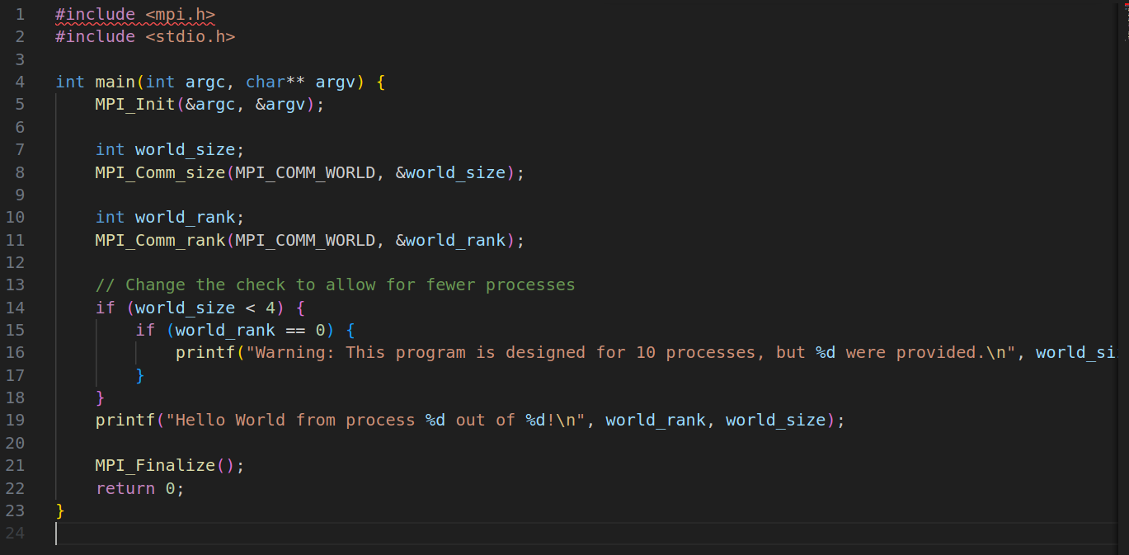

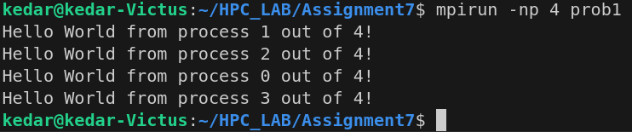

**Information 1:**

**Problem Statement 2:**

Implement a program to display rank and communicator group of five processes

**Screenshots:**

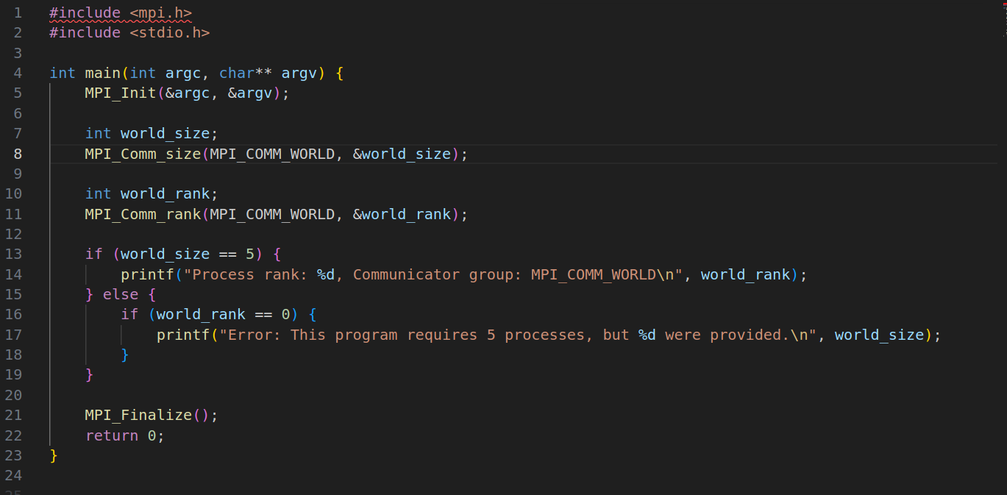

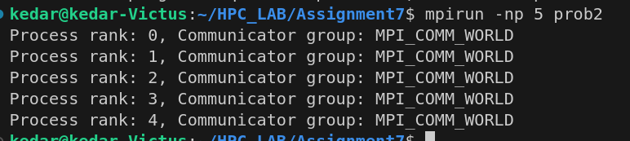

**Information:**